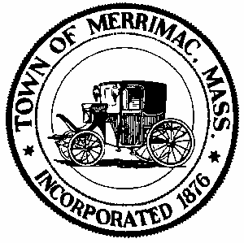
Town of Merrimac
School Street, Merrimac, Mass. 01860
TEL: 978-891-7238 | jsmith@townofmerrimac.com

Conservation Commission Meeting Minutes
Monday, September 22, 2025
Merrimac Public Library – Library Meeting Room

Meeting Cancelled

