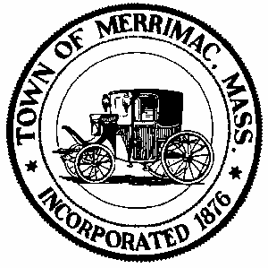
Town of Merrimac
School Street, Merrimac, Mass. 01860
TEL: 978-891-7238 | jsmith@townofmerrimac.com

Conservation Commission Meeting Minutes
Wednesday, August 25, 2025
Merrimac Public Library – Library Meeting Room

Members Present: Jerome Mathieu, chair; Greg Hochmuth, Greg MacLean, Bill Andrulitis, Mark Leger and Jay Smith, Conservation Agent.

The meeting was called to order at 6:04 PM

- Public Hearing: Notice of Intent: Applicant John Whittemore, RE construction of a retaining wall and patio at 25 West Shore Rd.
In attendance was Mr. Whittemore who discussed the project.

The Commission agreed that the plan drawn up by a landscape designer was insufficient as it lacked numerous details, such as dimensions. The meeting was continued allowing Mr. Whittemore time to come up with a more substantial plan.

- Discussion: Veterans Way Condo Association proposal for invasive species control.
In attendance were three members of the condo association who discussed their proposal for invasives removal in the buffer zone.

The Commission agreed unanimously (5-0) to the proposal and decided to issue a friendly Enforcement Order allowing the work to be done.

- Public Hearing: Request for Determination of applicability: Applicant Lake Attitash Association, RE: Installation of a phosphorus removal system at 128 Bear Hill Rd., Back River bridge.
Mark Leger recuses himself. Christine Leger, Robert Desmaris and Veronicia Lake were in attendance representing the Attitash Lake Association. They described the project using activated carbon and magnesium oxide in bags strung across the river to collect phosphorus. They stated no harm to the lake and the ingredients are used in water purification systems. Applicants will check the site once a month and remove prior to rain events. Data collected will be sent to the Commission.

The Commission with a (5-0) vote agreed to the proposition with a neg. Determination allowing the work to proceed. No Conditions were proposed because everything was already laid out in the Notice of Intent.

- Approval of Minutes: June 2, 2025

The minutes for July 28, 2025 were unanimously approved as is (5-0).

- Next Meeting: Monday, September 22, 2025

- Meeting adjourned 6:50pm.

