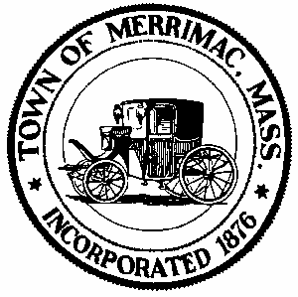**TOWN OF MERRIMAC**

**CONSERVATION COMMISSION**

**4 School Street, Merrimac, Mass. 01860**

**TEL: 978-891-7238 | jsmith@townofmerrimac.com**

**Conservation Commission Meeting Minutes**

**Wednesday, July 28, 2025**

Merrimac Public Library – Library Meeting Room

**MEETING CANCELLED**