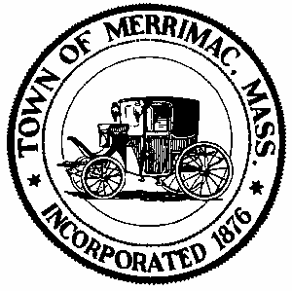
TOWN OF MERRIMAC
CONSERVATION COMMISSION
4 School Street, Merrimac, Mass. 01860
TEL: 978-891-7238 | jsmith@townofmerrimac.com

Conservation Commission Meeting Minutes
Wednesday, June 23, 2025
Merrimac Public Library – Library Meeting Room

Members Present: Jerome Mathieu, chair; Greg MacLean; Bill Andrulitis; Charlie Covahey, Mark Leger and Jay Smith, Conservation Agent.

The meeting was called to order at 6:06 PM

- Public Hearing: Request for Determination of applicability: 26 Church St., Applicant: Chris Woods., RE: Rebuilding a retaining wall.
In attendance were Bob Prokop and Chris Woods. Bob Prokop presented the Determination. Stockpiling of soil, old stone removal, silt fence location and access to site were brought up by the Commission.

Stones will be removed off site. The silt fence shall be installed at the top of slope and expanded and fill allowed to create access. The soil stockpile shall be placed upslope outside the silt fence. The Commission approved the issuance of a Negative Determination (5-0).

- Discussion: Veterans Way, invasives species problem
In attendance was Melvyn Ball and Raymond Orsini. The Site visit was discussed. Various methods for invasives removal were discussed.

The Commission asked for a plan and description to be submitted describing the area and work to be done.

- Discussion: Certificate of Compliance Request: 118E, Main St. DEP#45-302.
The As-built plan was reviewed along with COC filing.

With a unanimous decision the Commission approved the issuance of a Certificate of Compliance (5-0) pending removal of the erosion control.

- Discussion: 12 Red Oak Acres, possible violation.
A paved basketball court was installed in the buffer zone to a wetland without approval.

The Commission will draft a letter requesting that the applicant get in touch with a. Engineer or wetland scientist to put together an appropriate after the fact filing to be submitted as soon as possible.

- Approval of Minutes: June 2, 2025

The minutes for June 2, 2025 were unanimously approved as is (5-0).

- Next Meeting: Monday, July 28, 2025

- Meeting adjourned 7:00pm.

