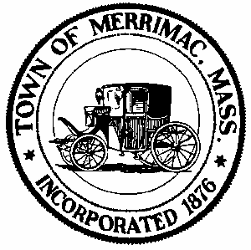**TOWN OF MERRIMAC**

**CONSERVATION COMMISSION**

**4 School Street, Merrimac, Mass. 01860**

**TEL: 978-891-7238 | jsmith@townofmerrimac.com**

**Conservation Commission Meeting Minutes**

**Monday March 31, 2025**

Merrimac Public Library – Library Meeting Room

**Members Present:** Jerome Mathieu, chair; Greg Hochmuth; Arthur Yarranton; Greg MacLean; Bill Andrulitis; and Jay Smith, Conservation Agent.

**The meeting was called to order at 6:00 PM**

**1. Public Hearing: Notice of Intent: 1 Liberty St., Applicant: Wojcicki Development Co., RE: Rehabilitating mill building, construction of a new building and site work.**

In attendance were Patrick Seekamp (wetland scientist). Steve Sawyer (Engineer) and Howard Snyder (Landscape designer). Paperwork including plans, NOI and stormwater report that had been submitted was presented by the applicant’s representatives. No DEP# as yet.

*Items raised included path location, dock, water line, snow storage, dumpster location, plantings, plan discrepancies and rain garden. The applicant’s representatives will review the comments and make adjustments for the next meeting. With the applicant’s approval the meeting was continued until the next scheduled meeting.*

**2. Discussion: Possible violation at 56 Birch Meadow Road.**

*The Commission asked Mr. Smith to talk to the owner to get permission to view the property.*

**3. Discussion: COC Request: 15 Hansom Dr, DEP# 45- 38.**

*Considering that the Order of Conditions was for the subdivision and not the individual lots and the lot is not near any wetlands, the Commission unanimously agreed to issuing a Partial Certificate of Compliance for the lot.*

**4. Discussion: OC Extension Request: 117 River Rd, DEP# 45-308**

Extension request was reviewed. Additional work still needed to be done on the Order of Conditions. Greg Hochmuth recuses self.

*In a unanimous vote (4-0) the Commission agreed to grant a three-year extension to the Order of Conditions.*

**5. Discussion: Possible violation, 10 North St., septic failure.**

Mr. Smith was denied access to the property. Additional information obtained from the Health Dept. indicated no visual appearance of septic overflow.

*The Commission unanimously agreed to wait and see how the Health Department handles the situation.*

**6. Discussion: Mark Leger, formal procedure for full membership.**

*Mr. Leger was formally made a full member of the Conservation Commission by unanimous decision.*

**7. Approval of Minutes: March 31, 2025**

*With a unanimous vote of approval (5-0) the minutes were approved as is.*

**8. Next Meeting: Wednesday, April 30, 2025**

**Meeting adjourned 7:35pm.**