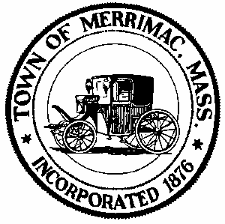**TOWN OF MERRIMAC**

**CONSERVATION COMMISSION**

**4 School Street, Merrimac, Mass. 01860**

**TEL: 978-891-7238 | jsmith@townofmerrimac.com**

**Conservation Commission Meeting Minutes**

**Monday February 24, 2025**

Merrimac Public Library – Library Meeting Room

**Members Present:** Jerome Mathieu, chair; Arthur Yarranton; Greg MacLean; Charlie Covahey; Bill Andrulitis; Mark Leger and Jay Smith, Conservation Agent remotely

**The meeting was called to order at 6:00 PM**

**1. Discussion: Possible violation at 56 Birch Meadow Road.**

Information obtained was reviewed.

*Continued to next scheduled meeting where a site visit date will be assigned.*

**2. Discussion: COC Request: 142 River Rd., Applicant Chris Ferrant, RE: septic system**

Mr. Ferrant did not attend the meeting. The agent explained what he saw at a site visit.

*The Commission signed off on the COC. Will be issued when the agent decides that the site is stable and the erosion control has been removed.*

**3. Approval of Minutes: January 27, 2025**

*Minutes for January were unanimously approved (5-0)*

**4. Next Meeting: Monday, March 31, 2025**

*Change of meeting date approved*

**Adjourned: 6:45pm**

**5. Executive Session: Conservation Restriction**

*Motion made to enter executive session by Mr. Yarranton, seconded by Charles Covahey.*

*Motion passes with unanimous vote (5-0).*