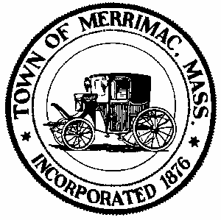
TOWN OF MERRIMAC
CONSERVATION COMMISSION
4 School Street, Merrimac, Mass. 01860
TEL: 978-891-7238 | jsmith@townofmerrimac.com

Conservation Commission Meeting Minutes
Monday, December 22, 2025
Merrimac Public Library – Library Meeting Room

Members Present: Jerome Mathieu, Greg Hochmuth, Greg McClain, Bill Andrulitis, Charlie Covahey and Jay Smith, Conservation Agent.

The meeting was called to order at 6:07 pm.

- Public Hearing: Request for Determination of applicability: Justin Craig, RE: Creation of a gravel parking area and septic and water tie in at 120A East Main St.
In attendance was Justin Craig who explained his submittal.

Greg Hochmuth explained that by including the septic line to the submittal would require the filing of a Notice of Intent because it involved work within a resource area. The Commission could issue a negative determination if the request for the sewer line were removed from consideration and all work be limited to outside the 25ft. no-disturb zone. The applicant asked to continue the hearing to think about his alternatives. The continuance was approved.

- Discussion: Certificate of Compliance Request, DEP# 45-316, 75 Hadley Rd.
The applicant was not in attendance. The agent explained the filing.

Considering no work had been done under the NOI the Commission unanimously approved the request.

- Discussion: Update on 12 Red Oak Acres violation and filing.
No filing has been received as of yet.

Considering the Commission has not been able to reach the Engineer the Commission will wait a little longer before deciding how to procede.

- Approval of Minutes: November 24, 2025

The minutes were approved as written with a unanimous vote of (5-0).

- Next Meeting: Monday, January 26, 2025

Meeting adjourned.

