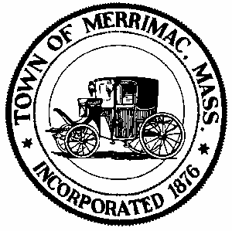
TOWN OF MERRIMAC
CONSERVATION COMMISSION
4 School Street, Merrimac, Mass. 01860
TEL: 978-891-7238 | jsmith@townofmerrimac.com

Conservation Commission Meeting Minutes
Monday, November 24, 2025
Merrimac Public Library – Library Meeting Room

Members Present: Jerome Mathieu, chair; Greg MacLean; Bill Andrulitis; Charlie Covahey, Mark Leger and Jay Smith, Conservation Agent.

The meeting was called to order at 6:10 PM

- Discussion: Annual Lake Attitash invasive plant report.
In attendance was Veronica Lake representing the Lake Attitash Association.
She explained the annual report. Invasive plants and their return in some areas was reviewed. A new invasive was identified. Treatment this June will be focused in Back River and Turtle Cove. Native weeds are becoming a problem to be addressed. The Association will continue as they have been with more emphasis on specific species.

- Discussion: Order of Conditions Extension Request, 1 Middle Rd.
Applicant was not in attendance so the agent reviewed the submittal.

J. Mathieu proposed a 1-year extension. Th Commission approved the proposal with a unanimous vote (5-0).

- Discussion: Updates on current projects: 25 River Rd., Wallace’s boat yard, 25 West Shore Rd., Liberty St. and 18, Harriman Rd.
The Agent gave the statis of the above projects. All going as planned.

- Discussion:120 E. Main St., Possible violation, Earth moving.
In attendance was the owner of the property.

The Commission explained that the owner would need to submit after the fact filing with Commission as soon as possible.

- Discussion: 73 West Shore Rd., Possible violation.
The agent described activity that occurred at the site involving tree cutting, grading and the creating a lawn.

The Commission agreed to take no action for now.

- Mark Tayler was recognized for his excellent work in the construction of a bench in the Town forest.

- Discussion: Request for an Open Space Planning Group member.

No takers as of yet.

- Approval of Minutes: October 27, 2025

The minutes were approved as is with a unanimous vote of approval (5-0).

- Next Meeting: Monday, December 22, 2025

- Meeting adjourned 7:35pm.

