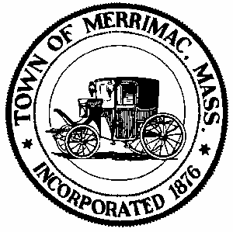
TOWN OF MERRIMAC
CONSERVATION COMMISSION
4 School Street, Merrimac, Mass. 01860
TEL: 978-891-7238 | jsmith@townofmerrimac.com

Conservation Commission Meeting Minutes
Monday, October 27, 2025
Merrimac Public Library – Library Meeting Room

Members Present: Greg Hochmuth, acting chair, Greg McClain, Bill Andrulitis, Charlie Covahey, Mark Leger and Jay Smith, Conservation Agent.

The meeting was called to order at 6:07 pm.

- Cont. Public Hearing: Notice of Intent: Applicant John Whittemore, RE construction of a retaining wall and patio at 25 West Shore Rd.
In attendance were Mr. Whittemore and his contractor. The work was explained. The existing wall will be removed and replaced by two walls to terrace the area. Pervious pavers will replace the ones existing currently on the same footprint. The stairway will be relocated. There will be less floodplain impact.

After a discussion, the issuance of an Order of Conditions was unanimously approved (5-0). Conditions imposed included Standard conditions, erosion control installation and inspection and advanced notice before work begins.

- Public Hearing: Request for Determination of applicability: Applicant David Graziano, RE construction of a replacement septic system at 18 Harriman Rd.
William Holt (engineer) was in attendance representing the applicant. He reviewed the plans and answered questions concerning the walls, stairs and the impervious pavers.

After hearing the presentation, the Commission voted unanimously to issue a negative 3 Determination (5-1). Conditions imposed included the Standard conditions and dirt storage outside the buffer zone, erosion control and inspection and notification prior to commencement of work.

- Public Hearing: Request for Determination of Applicability: Applicant N. E. Power Company, RE maintenance work for the power lines.
Applicant Hannah Raddatz, not in attendance. The Commission reviewed the Request paperwork and plans for powerline maintenance

The Commission found no objection to the maintenance plan presented. With a (5-0) vote the Commission unanimously approved the issuing of the Determination of Applicability with a negative 2 determination.

- Discussion: Violation: Jake Wallace for 103R River Rd: Failure to obtain an Order of Conditions
In attendance were Jake and Ms. Wallace owners of the property.

One of the Commission members explained to the Wallaces why a violation had occurred. Digging and ground disturbance were going on without a permit or approval from the Commission. Some erosion control was installed by the owners. G. Hochmuth and Jay Smith agreed to meet with the Wallaces at the site to discuss what they will have to do in terms of stabilization and requirements to begin work again.

- Approval of Minutes: August 25, 2025

- Next Meeting: Monday, November 24, 2025

Meeting ended 6:57pm.

