Identify and Prevent Rodent Infestations
You may never see a mouse or rat unless an infestation is severe. Look for signs of rat or mouse infestation:
- Rodent droppings around food packages, in drawers or cupboards, and under the sink.
- Nesting material such as shredded paper, fabric, or dried plant matter.
- Signs of chewing on food packaging.
- Holes chewed through walls and floors that create entry points into the home.
- Stale smells coming from hidden areas.
Discourage rats and mice from taking up residence on your property by removing food and water sources, and items that can provide them shelter:
- Seal holes inside and outside the home to keep rodents out. This may be as simple as plugging small holes with steel wool, or patching holes in inside or outside walls.
- Remove potential rodent nesting sites from your property, including leaf piles and deep mulch.
- Clean up food and water sources in and near your house.
  - Keep kitchen garbage in containers with tight-fitting lids.
  - Turn compost piles to cover newly added food scraps.
  - Stop feeding outdoor birds while you are controlling an infestation or feed only huskless items that leave less residue that can be food for rodents.

How to Control Wild Rodent Infestations
Rats and mice are known to carry many diseases. These diseases can spread to people directly, through handling of rodents; contact with rodent feces (poop), urine, or saliva (such as through breathing in air or eating food that is contaminated with rodent waste); or rodent bites. Rodents can also carry ticks, mites, or fleas that can act as vectors to spread diseases between rodents and people. Many diseases do not cause any apparent illness in rodents, so you cannot tell if a rodent is carrying a disease just by looking at it.
Infestation of rodents in and around the home is the main reason disease spreads from rodents to people. The best way to prevent a rodent infestation and contact with rodents is to remove food sources, water, and items that provide shelter for rodents. Learn how to eliminate a rodent infestation, prevent future rodent infestations, and prevent diseases spread by rodents.

Signs that Rodents are Present
The first signs of rodents usually appear before you even see a rat or mouse. Regular inspection of the inside and outside of a home or business is important to identify signs of rodents. It’s easier to control rodents before they have time to become established.

How to Seal Up to Prevent Rodent Infestations

Look for gaps or holes inside or outside your home
Keep rodents out of your house – check inside and outside for gaps or holes and seal any holes you find. Check for small and large holes – mice can fit through a hole the width of a pencil (1/4 inch or 6 millimeters in diameter).
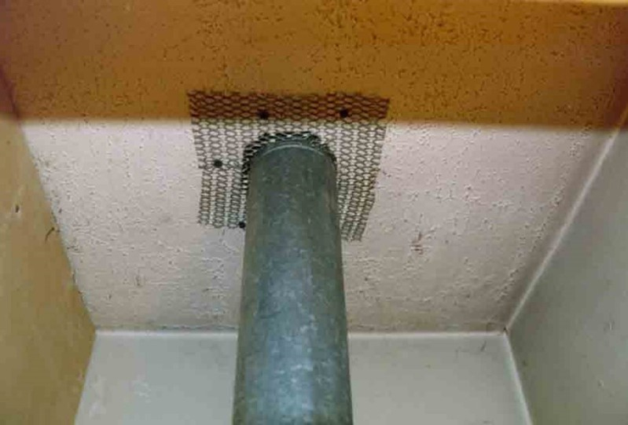
Using lath metal to seal gaps around pipes.

Inside your home: where to look
- Inside, under, and behind kitchen cabinets
- Floor areas in closets, especially corners
- Around the fireplace
- Around windows and doors
- Behind appliances
- Around the pipes under sinks and washing machines
- Around the pipes leading to water heaters and furnaces
- Around floor air and dryer vents
- Around all electrical, water, gas, and sewer lines
- Inside the attic
- In the basement or crawl space
- Around floor drains, such as in your basement or laundry room
- Between the floor and wall juncture

Outside your home: where to look
- In the roof among the rafters, gables, eaves, and soffits
- Around windows and doors (especially those without weather stripping)
- Between the foundation of the home and ground
- Around attic and crawl space vents
- Around holes for electrical, plumbing, cable, and gas lines
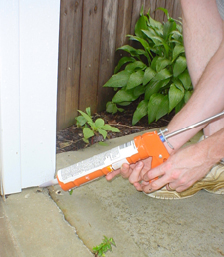
Using caulk to seal gaps between the home foundation and ground.

Seal up gaps and holes inside and outside your home
Seal any holes you find to stop rodents from entering. Fill small holes with steel wool. Put caulk around the steel wool to keep it in place or use spray foam. Use lath screen or lath metal, cement, hardware cloth, or metal sheeting to fix larger holes. Cut material to fit around pipes. Fix gaps in trailer skirting and use flashing around the base of the house. Outbuildings and garages should also be sealed to prevent the entrance of rodents.
We recommend contacting your local or state health department if there is concern of a rodent infestation or guidance is needed on what to do for a specific home or situation. A pest control specialist may be consulted if rodents have gotten into areas that cannot be reached to clean.

Seal up food and water sources inside your home
Rodents are attracted to food and water sources, as well as places that are convenient for them to build nests.
- Keep food sealed in thick plastic, metal, or glass containers with tight lids.
- Clean up spilled food right away. Wash dishes and cooking utensils soon after use.
- Put pet food away after use. Do not leave food or water bowls out overnight.
- Keep inside garbage in thick plastic or metal containers with tight lids. Frequently clean the containers with soap and water. Dispose of trash and garbage on a frequent and regular basis.

Seal up nesting sites and food sources outside your home
- Clean up garbage around your house. Use a thick plastic or metal garbage can with no holes and a tight lid.
- Keep outside cooking areas and grills clean.
- Keep composting bins at least 100 feet from your house.
- Keep bird feeders away from the house and use squirrel guards to limit access to the feeder by squirrels and other rodents.
- Keep grains and animal feed in thick plastic or metal containers with tight lids.
- Dispose of abandoned vehicles or move them more than 100 feet from your home.
- Move woodpiles 100 feet or more from your home and raise the wood at least one foot off the ground.
- Clean up brush and weeds around your home. Keep grass and shrubbery within 100 feet of your home well-trimmed.

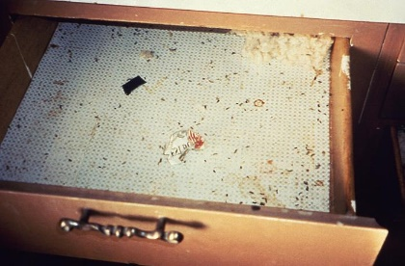
Two classic signs of rodent presence are rodent droppings (poop) and gnaw marks.
Two classic signs of rodent presence are rodent droppings and gnaw marks.
- Rodent droppings can be found anywhere rodents have accessed but are common in cabinets, drawers, and other areas out of plain sight. Rodent droppings are pointed at one end and often contain hair. It can be challenging to know if there is an active rodent population just by examining droppings. One way to be sure is to safely clean the area. If droppings are present after cleaning, this indicates an active rodent presence.
- Rats and mice gnaw to create better access points and keep their teeth at the proper length. Their teeth leave distinct marks and are a good sign that rodents were active in the area. Gnaw marks alone may only mean that rodents were active in the area at some point. Gnaw marks are often found in the same area as droppings, and the same clean-up techniques can be used to help determine if there is an active rodent presence.

Last Reviewed: January 3, 2023: Centers for Disease Control and Prevention, National Center for Emerging and Zoonotic Infectious Diseases (NCEZID)

